
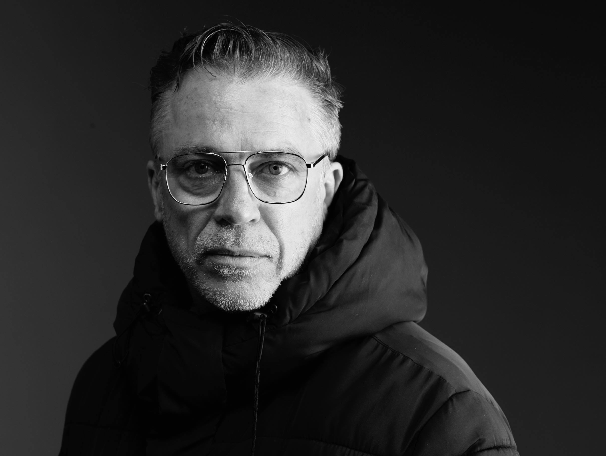 |  | Philip Channells  Creative Director / Producer
Profile  Award-winning creative director, producer, and industry mentor with 25 years at the forefront of dance in Australia and internationally. Renowned for championing artist-led initiatives, sector inclusivity, and cross-cultural partnerships, with a proven record of delivering innovative, high-impact projects. Specialist in community engagement, Accessible & Inclusive collaborations, and strategic sector development. 2025 Regional Arts Australia Fellow.  RECENT Key ACHIEVEMENTS  Recipient, Regional Arts Australia Fellowship (2025) – Professional development and international partnership-building in the UK.  Initiator & Leader: Dance Sector Uplift; engaged 120+ underrepresented artists and informed regional arts policy.  Contact  PHONE:  0432 073 304  WEBSITE:  philipchannells.com  EMAIL:  philipchannells@gmail.com |  | WORK EXPERIENCE  Dance Integrated Australia Creative Director / Producer  Dec 2012 – current  Collaborations with The Farm, Force Majeure, Bundanon Trust, SOH, West Kowloon, Garage Museum of Contemporary Art, ZODIAK. Developed inclusive, artist-led programs including Beyond Technique, Raconteurs, The Corner Dance Lab, MOVE IT Dance Fitness Fun, PRACTICE & PLAY and PH(R)ASE.  Arts Northern Rivers Research & Design Consultant  Dec 2022 – Dec 2023  Produced the Dance Sector Uplift project designed to reactivate and reinvigorate the dance, physical theatre and experimental performance sector of the NSW Northern Rivers region and collaborated with Patternmakers to co-design strategic tools for long-term sector resilience and growth.  Restless Dance Theatre Artistic Director  May 2009 – Jul 2012  Secured Australia Council triennial funding to expand touring and artistic programming. Pioneered inclusive professional programs recognising artists with and without disability as equals. Established the Debut mentoring initiative with Adelaide College of the Arts and led the company’s first international tour for DFAT’s Australia Week in Papua New Guinea, promoting cross-cultural exchange and inclusive practices abroad.  EDUCATION  Adelaide College of the Arts (formerly CPA & AIT), Adelaide SA  1998 - 2001  Bachelor of Dance Performance  REFEREES  Jane Fuller – Executive Director, Arts Northern Rivers  jane@artsnorthernrivers.com.au |T: 0420 701 614  Agnès Michelet – Artistic Director, Critical Path  director@criticalpath.org.au |T: 0481 383 662

